

**Student Name: Richard O’Shaughnessy**

**Student ID: A00178853**

**Web Site Address:**

**Course: H Dip in Computing**

**Date: 13/02/2014**

**Title of Assignment:**

**Word Count:**

# Description

Cool Quizzes is the best quiz site on the Internet. It has quizzes on all sorts of topics such as:

Maths Quiz: Tests your maths knowledge with an in depth maths quiz.

General Knowledge Quiz: Test your trivia knowledge with our trivia quiz

Picture Quiz: With this quiz, we will show you pictures of famous people and you can guess who it is.

# Purpose of the Website

The purpose of the site is to entertain quiz and trivia fans with an in depth quiz on a range of subjects

# Target Audience

The target audience is intelligent people who enjoy trivia and quiz games.

# Site Design

# Homepage Layout

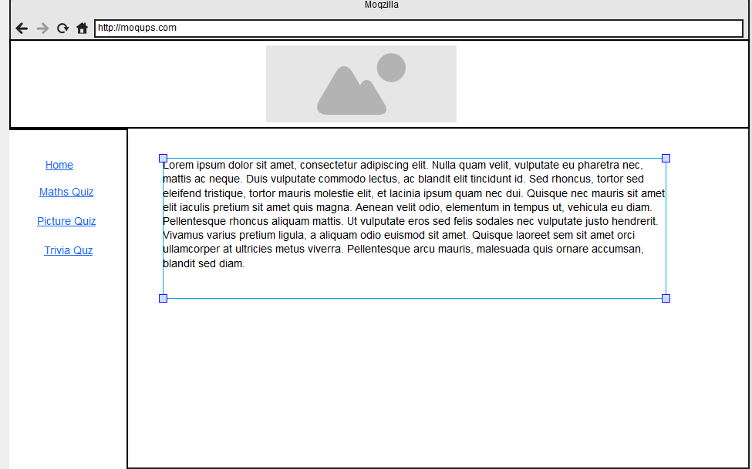

# Quiz Layout

# Site Content

## Home

The home page is the front page of the website. It has general information about the site and what it is all about. There won’t be any major information on this site, which will be deeper within the site.

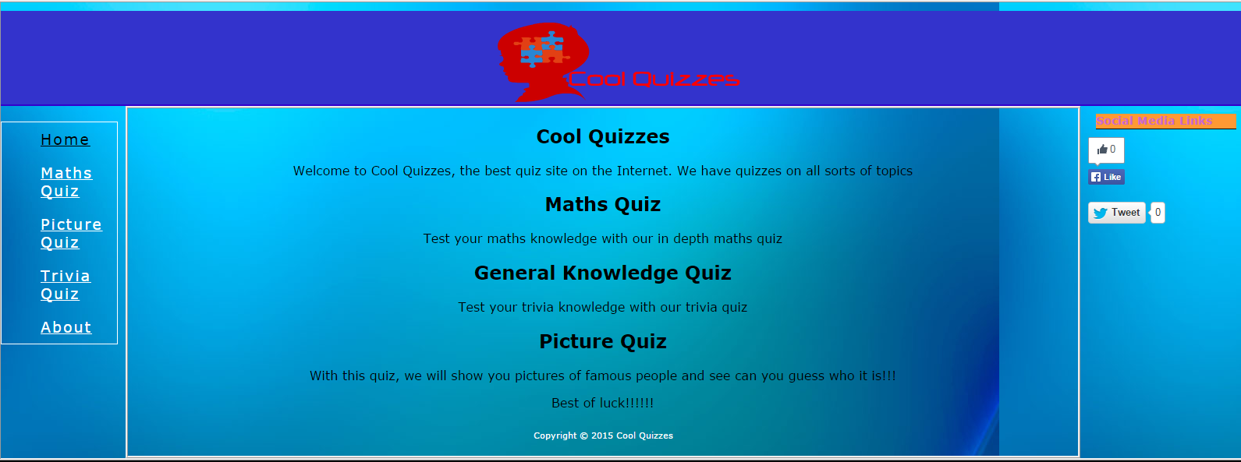

## Maths Quiz

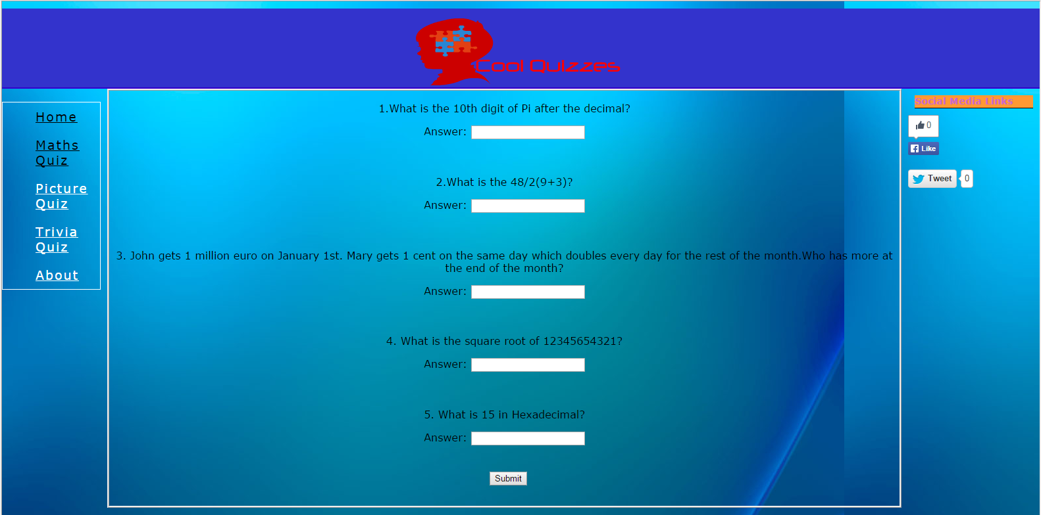

The maths quiz contains 5 questions with a text field underneath each question allowing the user to enter their answer. When the user has all questions entered, they click the submit button at the end of the quiz. They will then be told which answers they got right and which they got wrong. If they got any questions wrong they will be allowed to view the answer. At the bottom of the page, they will receive a final score. As well as that, when they hit submit, a sound effect plays depending on their score. If they get a good score, an audience clapping sound effect will play. If they get a bad score, an audience booing will play.

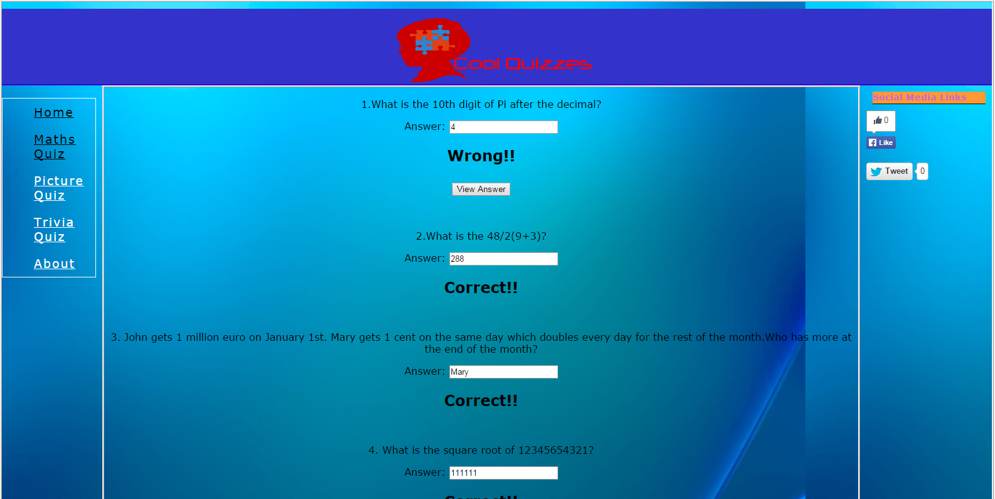

## Picture Quiz

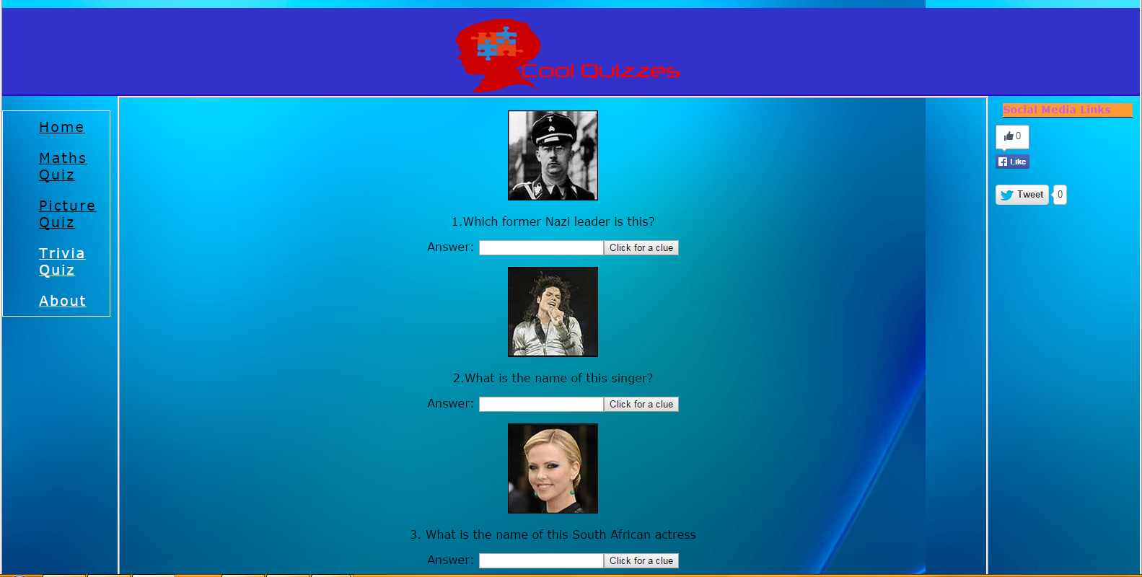

This works very similarly to the Maths quiz. A picture appears and the player must guess who the picture is of. If the user does not know, there is a button beside the textfield. If they press the button, a clue will appear to help them. When the quiz is finished, a new button will appear depending on how they answered each question. A button will appear if they get the question wrong, allowing them to see the answer. If they get it correct, a button will appear with an external link, allowing them to see more information about the answer. The same sound effect appears as after the Maths quiz.

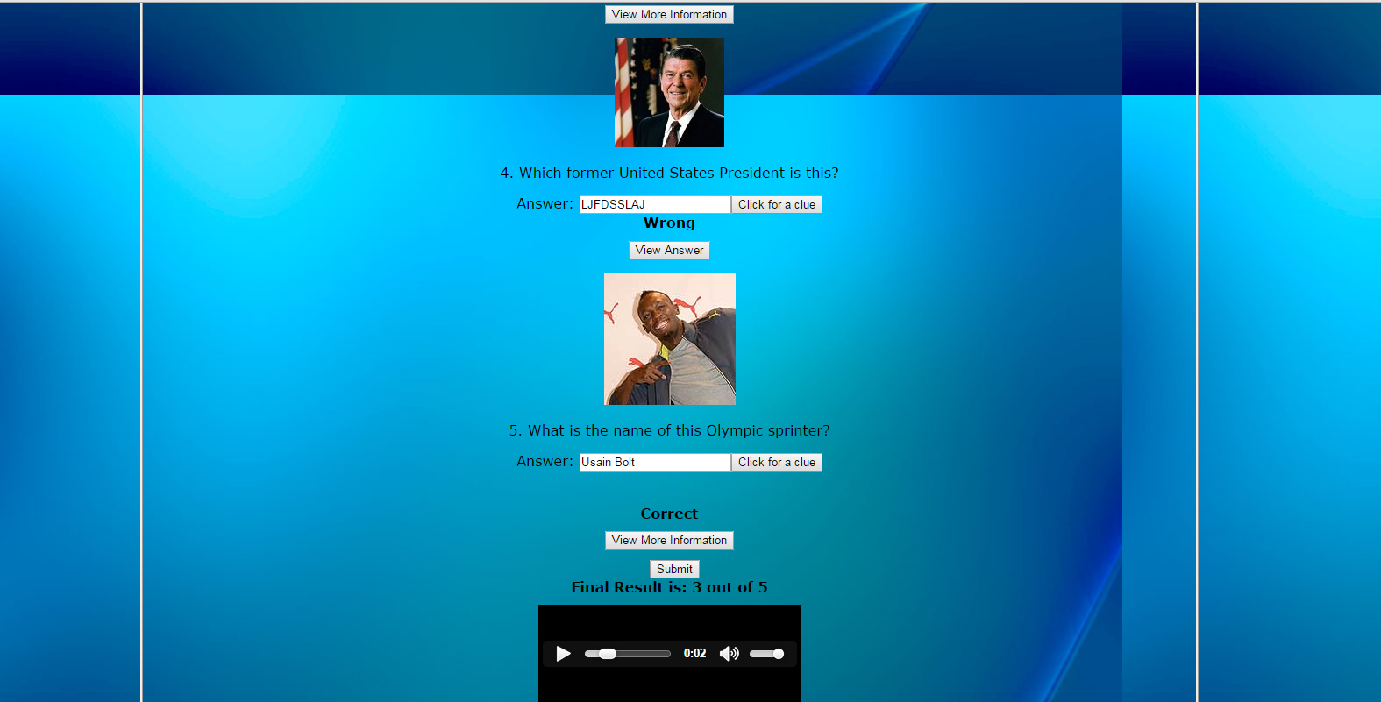

## Trivia Quiz

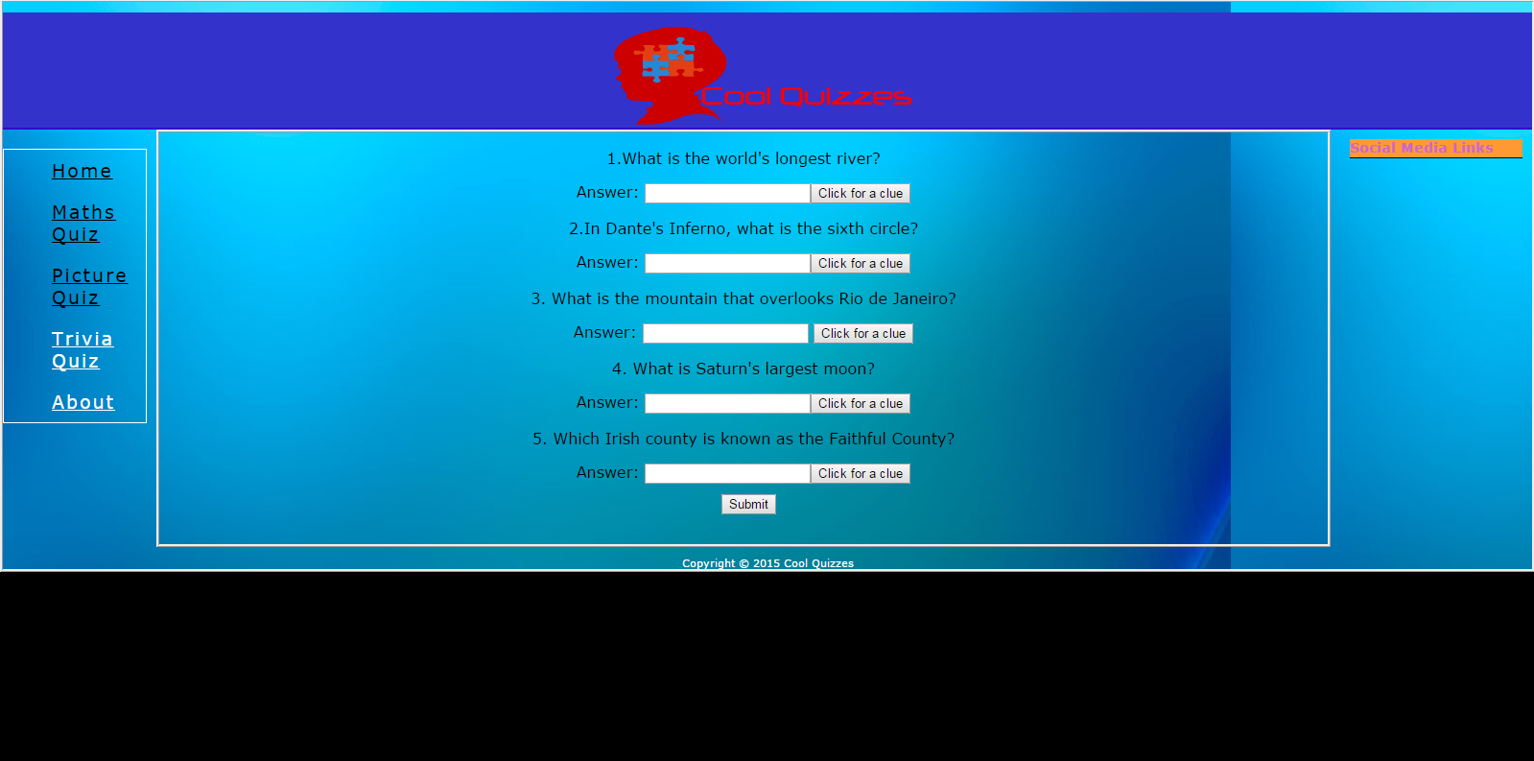

The trivia quiz contains 5 questions with a text field underneath each question allowing the user to enter their answer. When the user has all questions entered, they click the submit button at the end of the quiz. They will then be told which answers they got right and which they got wrong. If they got any questions wrong they will be allowed to view the answer. At the bottom of the page, they will receive a final score. As well as that, when they hit submit, a sound effect plays depending on their score. If they get a good score, an audience clapping sound effect will play. If they get a bad score, an audience booing will play. When the quiz is finished, a new button will appear depending on how they answered each question. A button will appear if they get the question wrong, allowing them to see the answer. If they get it correct, a button will appear with an external link, allowing them to see more information about the answer.

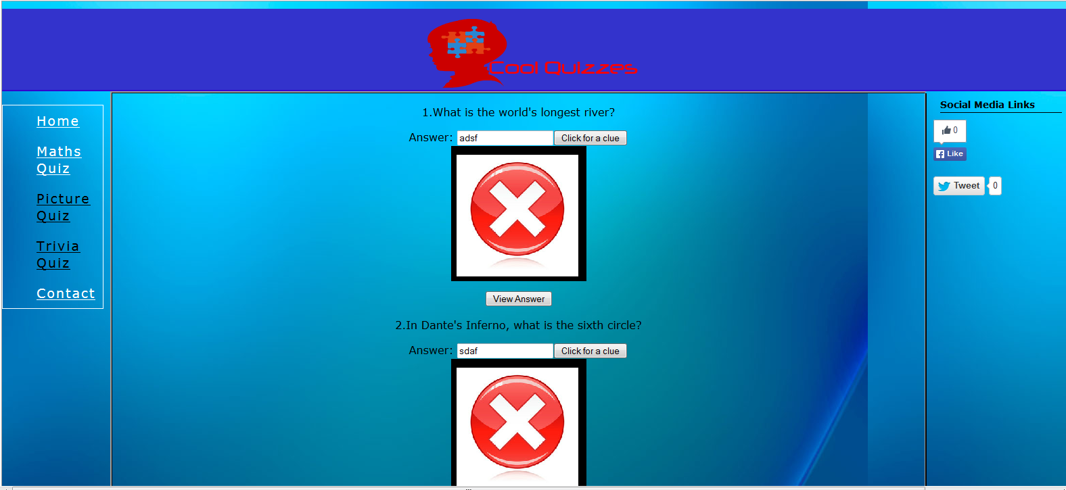

# Contact Page

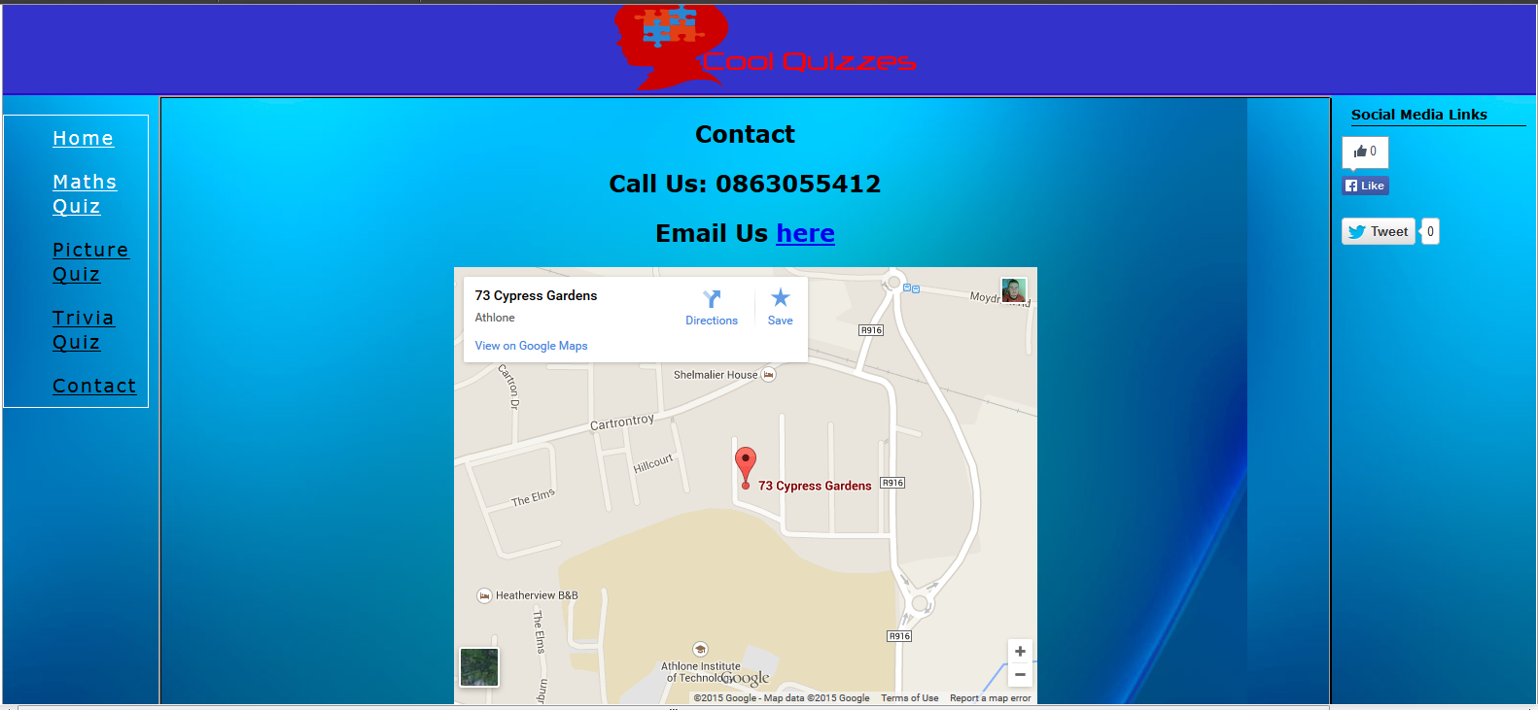

Contact page is a basic page with contact details for the company. There is a phone number, an email link and an embedded map from Google Maps to show the location of the company.

# Reflection

This project was interesting as it was my first real experience with using JavaScript. I have been doing computing for four years doing programming languages and websites and it was good to finally do a project using JavaScript which is one of the most important languages as most websites use it. I tried to expand the project to have small features. I brainstormed with two of my classmates, Deborah and Agnes and we all came up with the ideas such as linking to Wikipedia after the questions have been answered and showing correct answers and putting buttons in innerhtml. It was good to brainstorm the project and implement ideas that came from nothing and work with classmates on it. I am generally proud of being able to get these features working without much trouble.

CSS Is where I had most trouble. Where coding and programming is my stronger skills, CSS and design are not my strongest skills and although my site looks ok I know it could be better.